#### **Bedside drawer**

#### **Project overview**

I have created a bedside drawer, which consist of a drawer, the drawer has an RFID locking technology. Inside the drawer there are USB ports and a wireless charger which can be used to charge any device and a NeoPixel digital RGB led strip all around the inner edges when user opens the drawer the leds will automatically turn on. At the front of the drawer there is an LCD screen which displays information to the users, such as when the drawer is locked and unlocked, it also displays username.

#### **Background research**

The theme I have chosen for my project is comfort zone, I wanted to create something for the user which will make it easier for them to store their important documents and devices safe and secure to prevent unauthorised access and to make it easier for the charge their devices.

I conducted a market research to find similar projects already exists. I didn’t find any project that had the features I was thinking of implementing in my project however I came across Pankaj blog [1]. In this project he has created locking mechanism for door using RFID tag as a key to authenticate access and it uses buzzer to alert the user if wrong card is used.

I did some research on Usb ports, I wanted to know how the Usb ports works and how I can create them for my project. I found a tutorial online [2], which showed a step by step instruction on how to create it and the materials I will need.

I did some research on how RFID works. It was important for me to understand the theory behind how RFID work, because RFID is core part of my project. I found a guide [3] I used to enhance my understanding about RFID.

I looked at different locking mechanisms online. For my project I needed to create a locking mechanism which the RIFD will use to lock and unlock the drawer. Locksmith [4] had different locking mechanisms which are currently used everywhere, it also has pros and cons of each mechanism. It gave me a rough idea of what kind of locking mechanisms I need to create for my project.

I also did some research online to find out more about display screens, I will be using a screen in my project, which will display feedback given to user when they perform a specific action. I looked at an article [5] which explained the differences between LED and LCD display screens, and I compared the two to decided display which one to use.

#### **Context, Users/Audience, Goals**

My product can only be used at home or in the office. It can only be used indoor.

My product is aimed for anyone age of 14 and over, it can be used to store documents and electronic devices safe and secure, because it has a locking mechanism. The users can also use the drawer to charge their devices through cable and if their device supports wireless charging, they also charge their device by placing on the wireless charger. If they are using the drawer at night, it has NeoPixel digital RGB led strip which will automatically turn on at night making visibility easier for the user. The LCD displays the name of the user and feedback for their action.

#### **Project in Depth**

A detailed description of the final output:

Here are some of the key features of my product:

* The bedside table has RIFID tag locking mechanism, which allows the user to lock and unlock the drawer by taping a card. The drawer can only be unlocked with registered cards, if the card is not registered and the user tries to use it, it will deny their access and they won’t be able to unlock the drawer.
* It allows the user to register more than one card using the master card, when the user taps the master card twice an option appears on the screen asking the user to touch new card and once they touch it automatically registers the card.
* It allows the user to easily remove a card they no longer need, this can be done using their master card, when the user taps the master card an option appears on the screen asking the user to tap the card and if they touch the card that already exists, it automatically gets deleted from the system and that card can no longer be used to unlock the drawer unless they register it again.
* The screen on the drawer displays clear instruction to the user, it provides useful feedback to user whenever they perform any action.
* The screen displays name of the user.
* The drawer automatically locks when the user closes the drawer, and it displays on the screen the drawer is locked.
* The drawer has NeoPixel digital RGB led strip inside which the user can simply turn on plug it in, in the Usb socket.
* The drawer has USB port which the user will to charge their device.
* There is also a big storage space at the bottom of drawer which user can use to store bags and use it store books or CDs.
* Supports wireless charging if the user has a device that support wireless charging, they can charge it wirelessly.

**Libraries**

These are the libraries I have used:

* SPI.H
* MFRC522.H
* LiquidCrystal.h
* Servo.h
* Adafruit NeoPixel

**Software’s**

These are the software’s I have used:

* Adobe illustrator: I used this software to create a design for my bedside table, I had to use this software because this was the only software that was compatible with the laser cutter at my university.
* Arduino: this was the software I used to write code and program my Arduino metro.

**Hardware**

These are the hardware’s I have used:

* **Laser cutting machine:** I used laser cutting machine to cut the wood for the bedside drawer.
* **Proximity sensor:** I used proximity senor to detect wither the drawer is open or closed, if it detects the drawer is closed it will automatically lock the drawers
* **Screens:** to display feedback to the user on their actions and provide feedback.
* MFRC-522 RFID IC card inductive module
* **S50 white card:** to register with RFID module.
* **Wood:** to make the drawer.
* **Cardboard:** to make a prototype for the project.
* **Metro board:** to power up all my components and to program them.
* **Resistors:** to provide the power need to avoid damaging the components
* **Neo pixels RGB led Strips:** to light up the drawer when its dark.
* **Servo motor:** I used servo motor to create locking mechanisms.
* **Power bank:** to power the Arduino and charging facility.

**Code**

For the Neo pixels Rgb Led strip I wrote the code myself from scratch, the code can be seen in the led walk folder.

For the RFID tag and screen, I used code from different libraries and combined them together to make it work for my project.

#### **Creative Process**

Initially I made prototype from cardboard which can be seen in appendix, when creating the first prototype I didn’t have all my components I needed so I drew each of the component I was going to use and wrote an explanation for each of the components and how it’s going to work. I explained all the features I was going to have shown in figure 1. I asked the user for feedback. The users made a few suggestions. User feedback can be seen in appendix

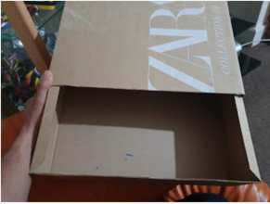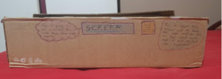

Figure Shows first design

Taking the user feedback into consideration I made changes to prototype as suggested by the users I got rid of features they didn’t like such as power socket. Instead of power socket I decided to have Usb ports and instead of it been just a drawer I designed a bedside table. It consisted 3 drawers only one the drawer had RFID locking system and the rest were normal drawers. I asked the users for feedback. The user liked the design however they suggested to get rid of the other 3 drawers have only 1 drawer and leave the other space for storage. More images in appendix.

Taking user feedback into consideration I made another protype as seen in figure 2, I removed the other 3 drawers and I only kept one drawer and all the other features I kept the same. I asked the user for their feedback they user was happy with design however they suggested to have switch which can be used to turn off the RGB lights, instead of it automatically turning on and off. Overall, they were happy with the design.

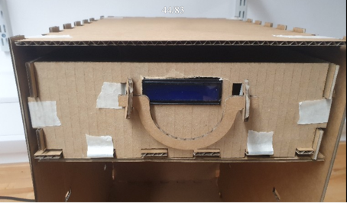

Figure shows 3 iteration

**Final design**

Taking all the feedback I received from the user into consideration, I created my final design as seen in figure 3. I am made the changes suggested by the users such as I removed the power socket instead, I decided to have Usb ports. I also made a partition in the drawer where the user will place their phone. Once I made my final iteration, I asked the users for feedback and upon approval from the user I moved to the developing final product. More images in appendix.

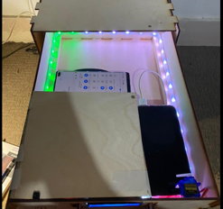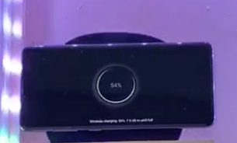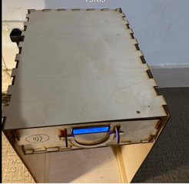

Figure

#### Debugging and Problem Solving

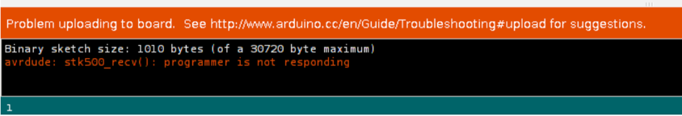

Figure

One of the problems I encountered was my Arduino would connect to my computer, all the setting was correct but every time a code was uploaded, I would get an error message shown in figure 4. I tried to reset the Arduino, I tried using different USB cable, but it still didn’t fix the issues. I watched different tutorial I didn’t help. I read a post [6] on stack overflow someone else using mac has a similar issue and they suggested when using uploading the code and the light blinks in Arduino. I need to press reset button and the it would upload, and it worked.

Another issue I had was when I connected the LCD screen to my Arduino, it was working fine but when I connected NeoPixel RGB strip to same Arduino, my screen would stop working and when I unplugged NeoPixel RGB strip, the screen would work fine. I tried to debug this issue by watching online tutorials, read forums, I asked my friends, but I was not able to debug it, so I decided to a separate Arduino for NeoPixel RGB strip.

#### **Evaluation**

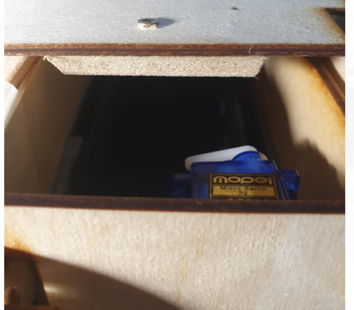

Figure Door locking mechanism

Overall, my project was successful I managed to meet all my goals as I planned at the start of the implementation. I also did user testing and the responses were mostly positive which shows it has been successful. However there are a few things I could have done better currently I am using a power bank to power most of the components, and the power bank is run by battery if there is no charge in power bank no one of the components will work, the user has to charge the power bank. The l lock I have created is not very reliable this due to the motor I have used as ***shown in figure 5***. When the proximity sensor detects the drawer is locked, the motor turns 90 degree locking the drawer if the user pulls the drawer handle hard it will break.

For the wireless charger I was going to use power management IC manufactured by adafruit, when I received the part, I wasn’t able to use it because it required 9v whereas my Arduino only provides 5v. I had order another one and use power bank to power it. Another change I made to my goal was instead of using USB socket I decided to use a power bank which has two Usb ports one is used to power Arduino and other port can be used to charge other devices.

I carried out a lot of testing when my project was completed, user testing shown in appendix, I got the users to test each part of the project. These tests I carried out were important because, I had to make sure each feature works as expected and it also helped me to analyse how successful my project has been.

My creative process worked well because I kept referring back to user and I kept asking them for feedback and I kept iterating my product and repeating the process again before making my final product. One thing I could improve could be to make a protype that would work exact same as how final product will work but because I didn’t have all the components I needed when creating prototype.

My problem solving was good, I was able to solve the problems I faced by watching tutorials and reading online threads, I could improve it by going deep into problems and see what could have caused it and why instead of just looking for solution.

In future I would add more features such as security alarm when someone tries to open without permission an alarm will go on. I will also make the size of the drawer bigger and add more drawer each drawer will have RFID locking machines.

#### **Bibliography**

[1] Pankaj khatri, P.K. 2018. CirciutDigest. [Online]. [11 January 2020]. Available from: <https://circuitdigest.com/microcontroller-projects/arduino-rfid-door-lock-code>

[2] Severepb, S.E. 2007. How to Make 1 Usb into 2, or More. Instruct-able Circuit. [Online]. [15 December 2019]. Available from: <https://www.instructables.com/id/how-to-make-1-usb-into-2-or-more/>

[3] Unknown , U.K. 2019. WHAT IS RFID? | THE BEGINNER'S GUIDE TO RFID SYSTEMS. [Online]. [17 December 2019]. Available from: <https://www.atlasrfidstore.com/rfid-beginners-guide/>

[4] Unknown . 2017. Door locks types. [Online]. [20 December 2019]. Available from: <https://www.locksmiths.co.uk/faq/door-lock-types-guide/>

[5] Quentyn kennemer and ryan waniata . 2019. Digital trends. [Online]. [25 December 2019]. Available from: <https://www.digitaltrends.com/home-theater/led-vs-lcd-tvs/>

[6] Peter mortensen. 2013. Stack overflow. 18 nov. Arduino Sketch upload issue. [Online]. [30 December 2019]. Available from: <https://stackoverflow.com/questions/19765037/arduino-sketch-upload-issue-avrdude-stk500-recv-programmer-is-not-respondi>

#### **Appendix**

* A link to GitLab <https://github.com/mkhan012/PhysicalComputingProject>
* Links to video recordings of product <https://youtu.be/sIpklMZHM_Q>
* Link to blog: <https://mkhan012physicalproject.blogspot.com>
* User testing/user feedback and other evidence can be seen below

**1st prototype**

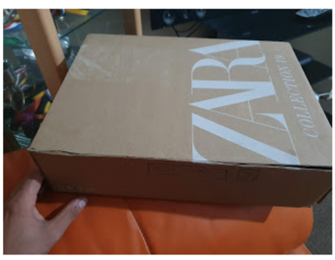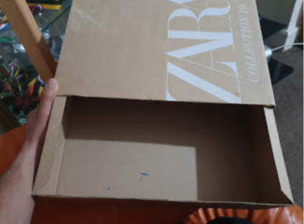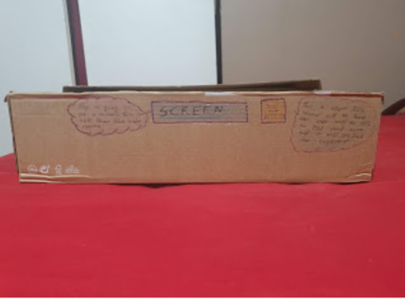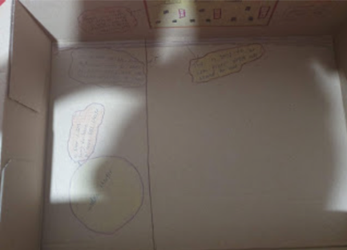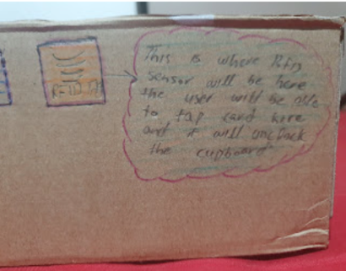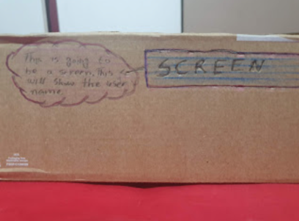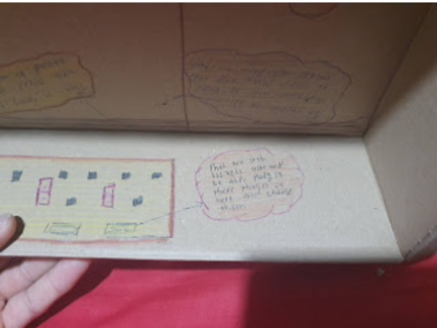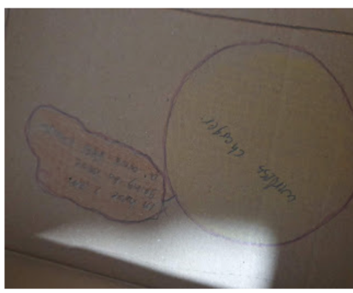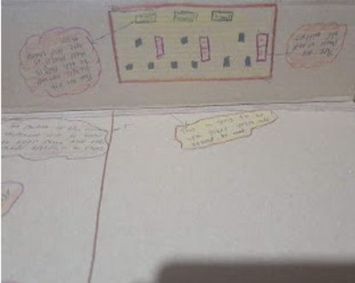

**2nd Prototype**

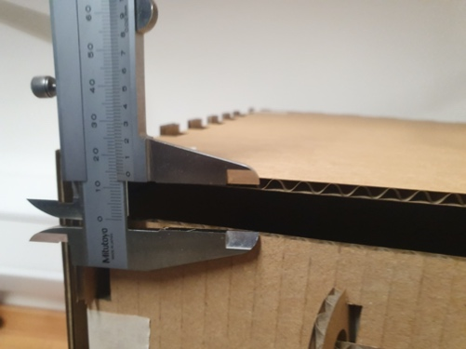

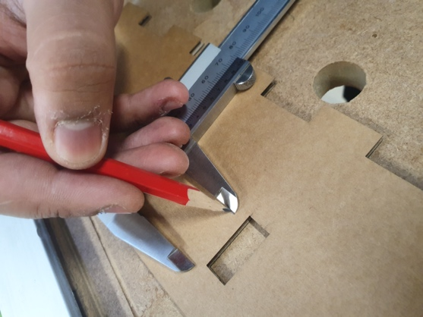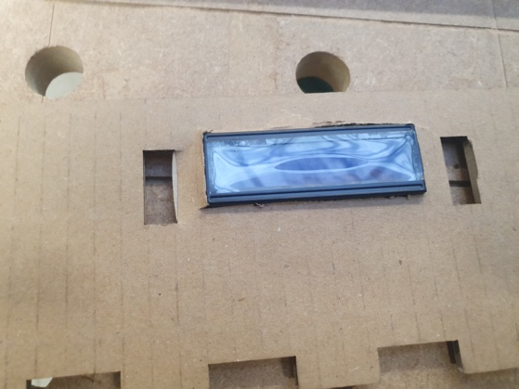

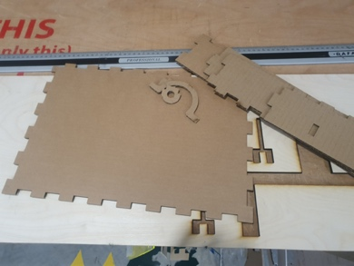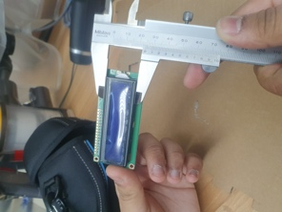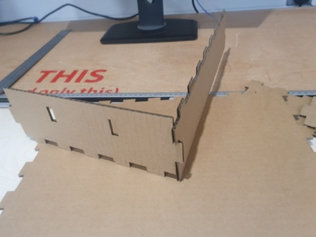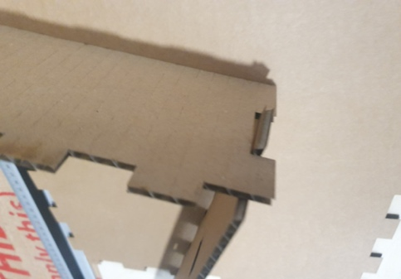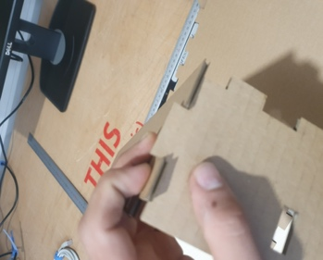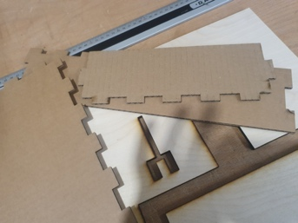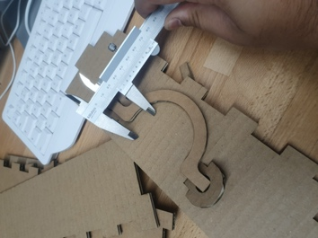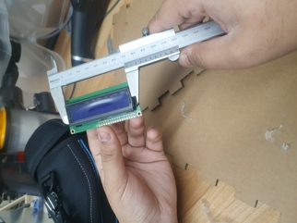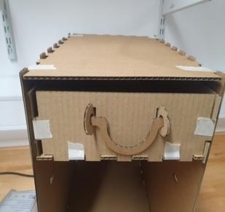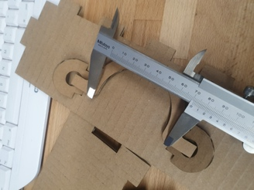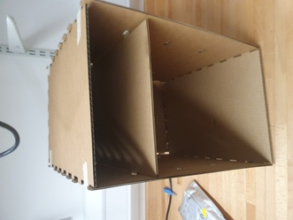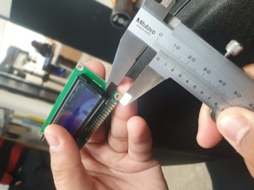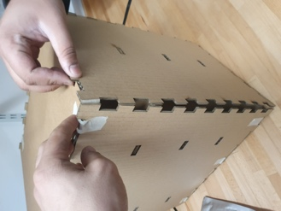

**Development process**

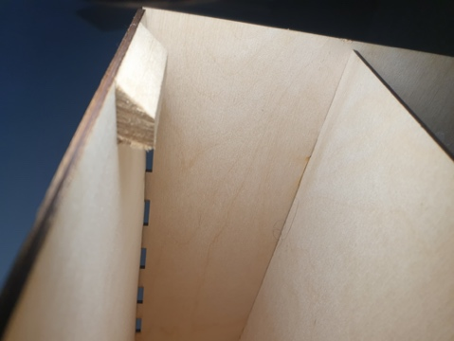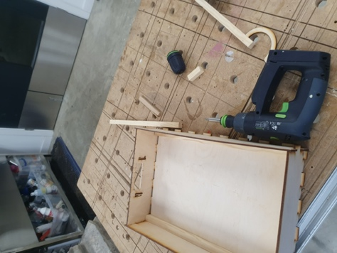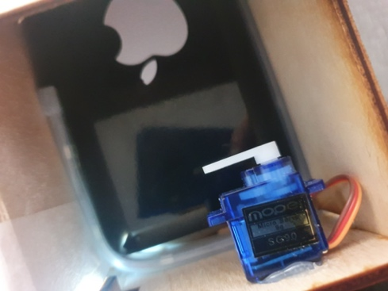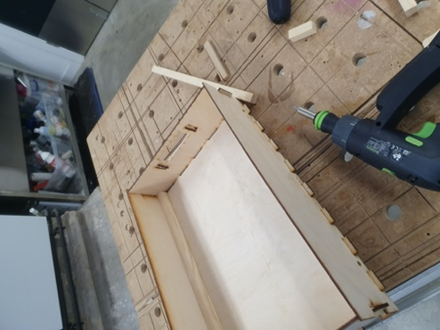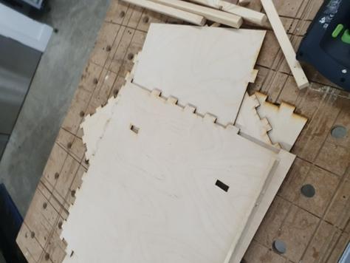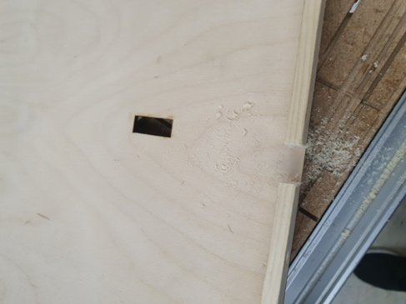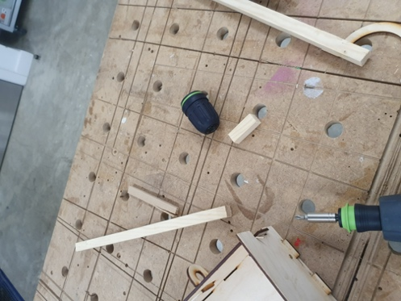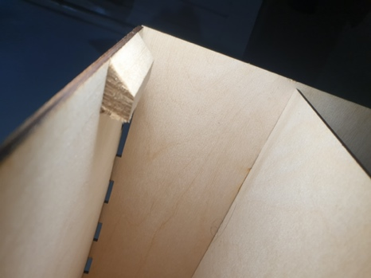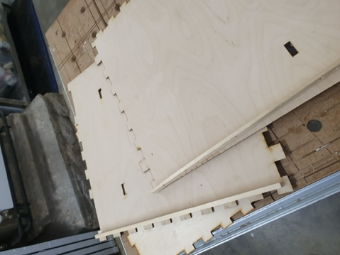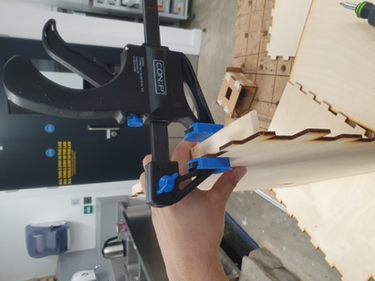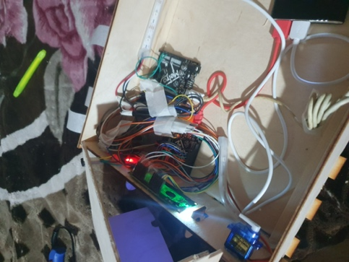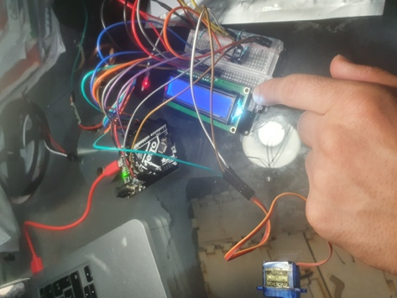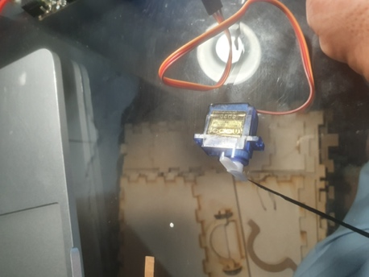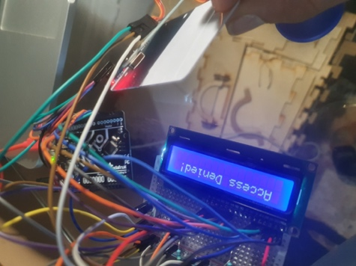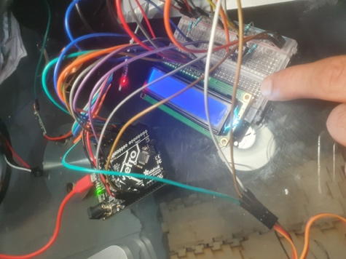

**Finished Product**

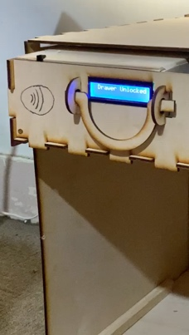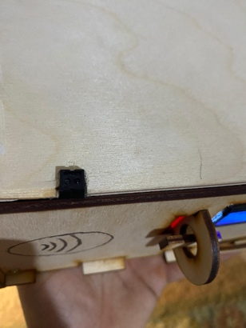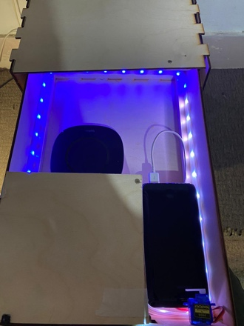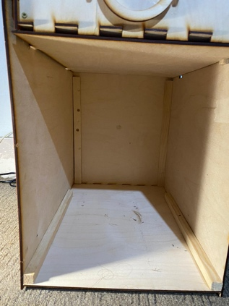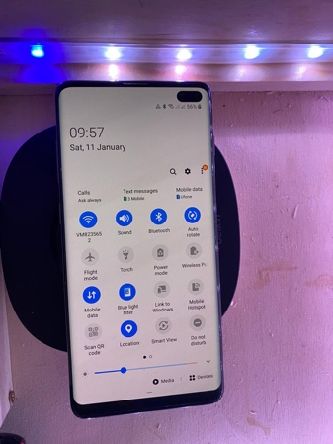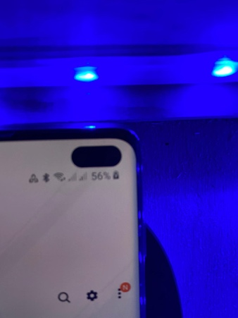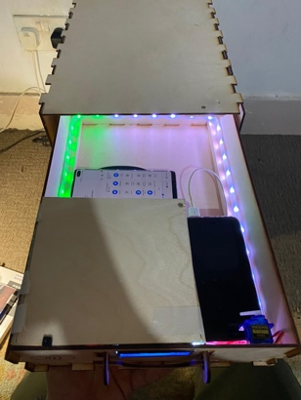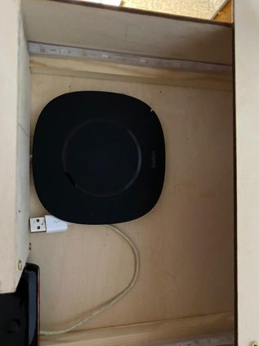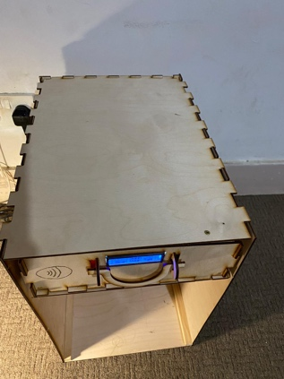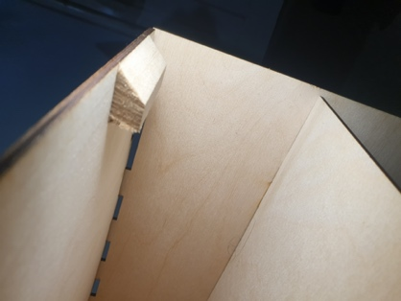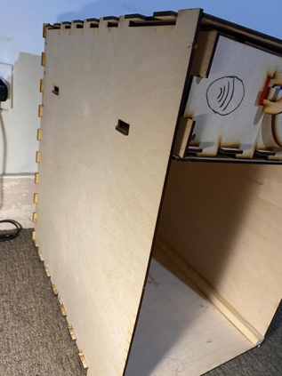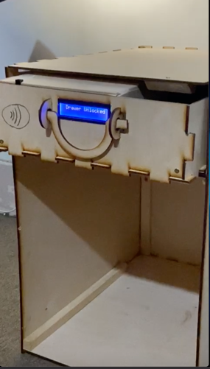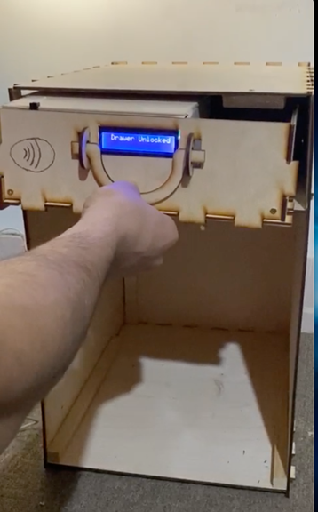

**User Tests Transcripts**

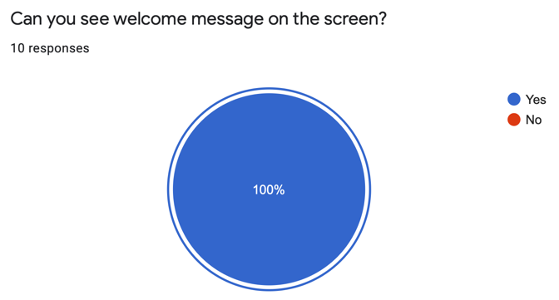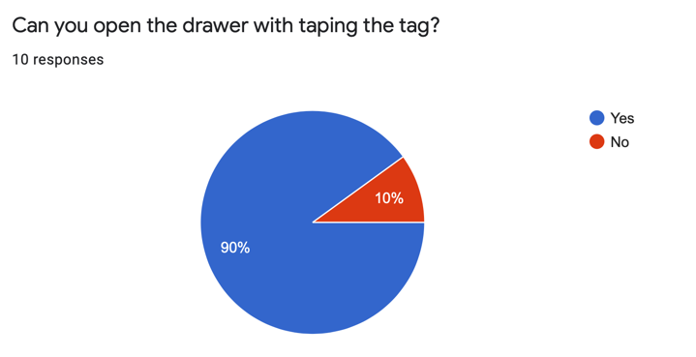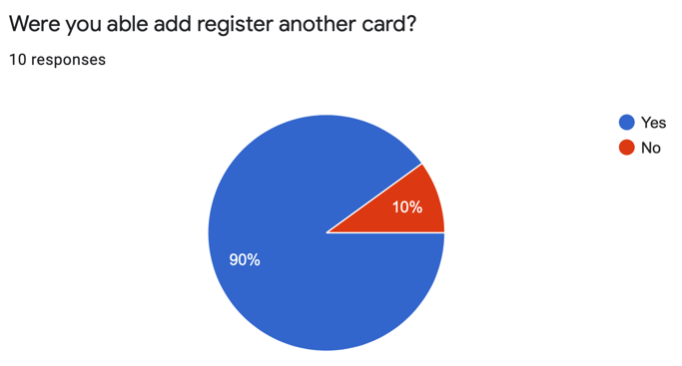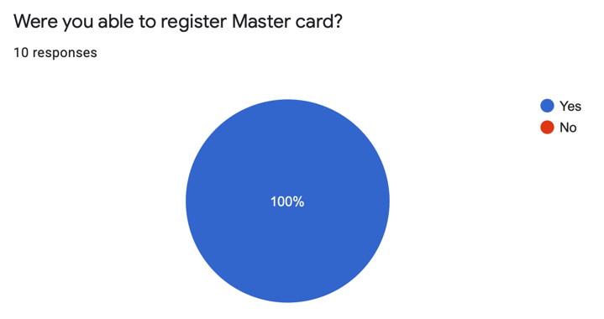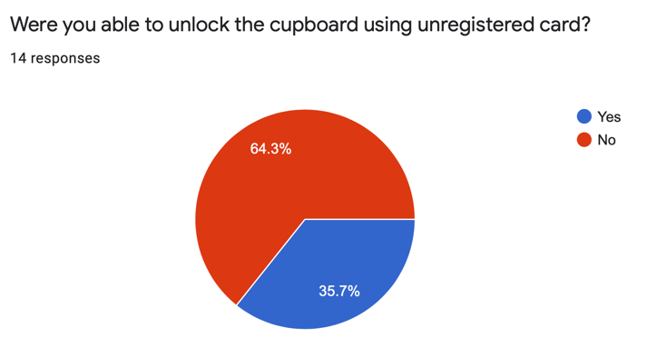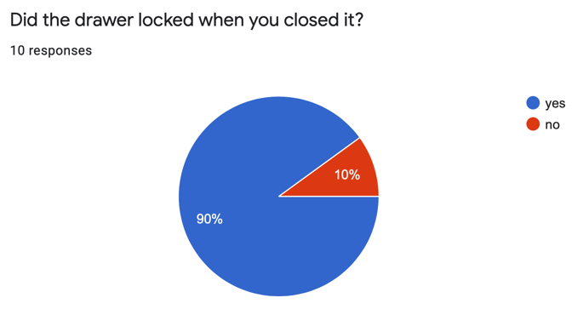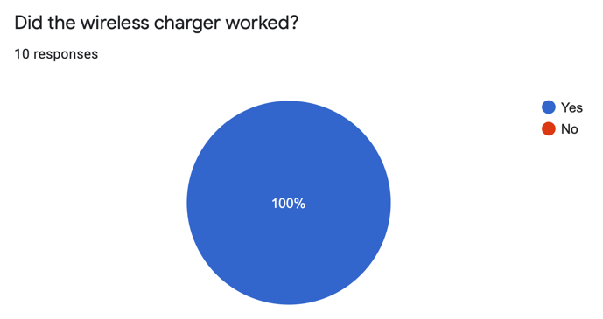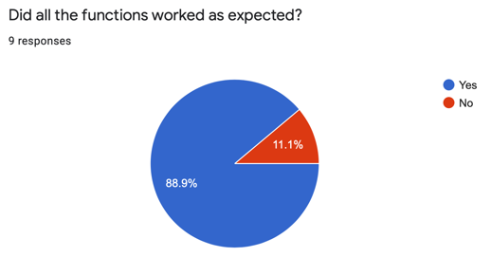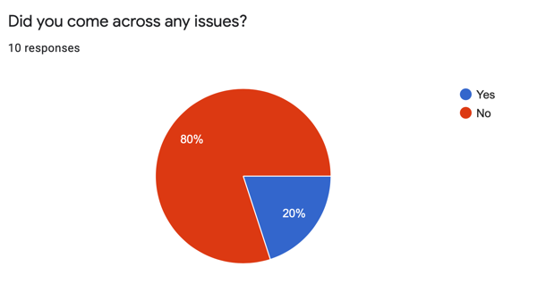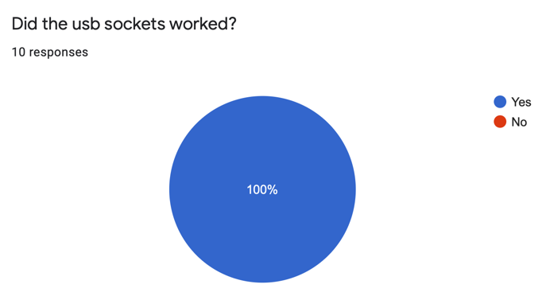

**Users Feedback**

